 |  | JURONG JUNIOR COLLEGE  JC 2 PRELIMINARY EXAMINATION  Higher 2
CANDIDATE
NAME

CLASS |  |  |  | EXAM INDEX NUMBER
CHEMISTRY |  |  |  |  | 9647/02
Paper 2 Structured Questions |  |  |  |  | 27 August 2010
 |  |  |  |  | 2 hours
Candidates answer on Question Paper.
Additional Materials: Data Booklet
READ THESE INSTRUCTIONS FIRST
Write your name and class on all the work you hand in.
Write in dark blue or black pen on both sides of the paper.
You may use a soft pencil for any diagrams, graphs or rough working.
Do not use staples, paper clips, highlighters, glue or correction fluid.

Answer all questions.
A Data Booklet is provided. Do not write anything on the Data Booklet.
At the end of the examination, fasten all your work securely together.
The number of marks is given in brackets [ ] at the end of each question or part question.
 |  |  |  |  |  |  |  | For Examiner’s Use
 |  |  |  |  |  |  |  | 1
 |  |  |  |  |  |  |  | 2
 |  |  |  |  |  |  |  | 3
 |  |  |  |  |  |  |  | 4
 |  |  |  |  |  |  |  | 5
 |  |  |  |  |  |  |  | 6
 |  |  |  |  |  |  |  | Total
This document consists of 15 printed pages and 1 blank page.
[Turn over

1. | Planning (P)
You are provided with 5 unlabelled bottles containing pure natural acids from the extracts of fruits.
Each bottle contains one of the following natural acids.
- quinic acid,
OH
CO₂H
HO
HO
HO

- maleic acid,
HO₂CCH=CHCO₂H
- pyruvic acid,
CH₃COCO₂H
- oxalacetic acid,
HO₂CCOCH₂CO₂H
- lactic acid,
CH₃CH(OH)CO₂H
You are also provided with any other common laboratory reagents and apparatus.
 | (a) | All natural acids contain one or more carboxylic acid functional groups.  Other than the carboxylic acid functional group, what other functional groups are present in these 5 natural acids?
 |  | quinic acid : ................................................................................................  maleic acid : ................................................................................................  pyruvic acid : ...............................................................................................  oxalacetic acid : ................................................................................................  lactic acid : ................................................................................................ | [1]

 | (b) | Two of these natural acids are colourless liquids and the rest are white crystalline solids.  Using relevant chemical knowledge, identify the two liquids. Explain your choices.
 |  | Two liquids are ...................................................................................................  Explanation: ........................................................................................................  .............................................................................................................................  .............................................................................................................................  ............................................................................................................................. | [2]

1. | (c) | Suggest a reagent that could be used to carry out a test-tube experiment to distinguish these two liquids.
 |  | Reagent: .............................................................................................................
 |  | Describe what would be observed for each compound in the experiment.
 |  | Observation: .......................................................................................................  ............................................................................................................................. | [2]
 | (d) | Outline a logical sequence of chemical tests that would enable you to identify the remaining 3 solids.  Your plan should include  - different positive test for each compound;  - a detailed procedure (including apparatus, quantities of chemical and conditions used);  - the expected observations for each compound in each test.
 |  | .............................................................................................................................  .............................................................................................................................  .............................................................................................................................  .............................................................................................................................  .............................................................................................................................  .............................................................................................................................  .............................................................................................................................  .............................................................................................................................  .............................................................................................................................  .............................................................................................................................  .............................................................................................................................  .............................................................................................................................  .............................................................................................................................  .............................................................................................................................  .............................................................................................................................  .............................................................................................................................  ............................................................................................................................. | [5]

1. | (e) | How would you ensure the reliability of the test result for quinic acid.
 |  | .......................................................................................................................................................................................................................................................... ............................................................................................................................ | [1]
 | (f) | Suggest a safety precaution that you will consider in carrying out your plan.
 |  | ....................................................................................................................................................................................................................................................................................................................................................................................... | [1]
 |  | [Total: 12]

BLANK PAGE
2. | The kinetics of the reaction between 2−bromo−2−methylpropane and aqueous sodium hydroxide can be investigated experimentally via a ‘clock experiment’.  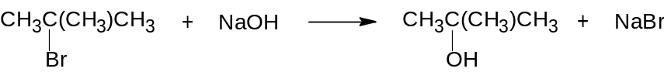  A few drops of phenolphthalein were added to a sample of sodium hydroxide. When a measured amount of 2−bromo−2−methylpropane was added to the sample, the mixture was vigorously shaken and a clock was immediately started. The time taken for the pink colour of the indicator to disappear was recorded.  This experiment was repeated twice using different concentrations of the two reactants. All experiments were carried out at the same temperature.  The results obtained are recorded below.
  Experiment | [2−bromo−2−methylpropane] / mol dm⁻³ | [sodium hydroxide] / mol dm⁻³ | Time / s
  1 | 0.011 | 8.00 × 10⁻⁴ | 32
  2 | 0.022 | 8.00 × 10⁻⁴ | 16
  3 | 0.022 | 1.60 × 10⁻³ | 32
  4 | 0.044 | 4.00 × 10⁻⁴ | x
 | (a) |  | Explain why the pink colour of the indicator disappeared.
 |  |  | ………………………………………………………………………………………….. |  |  |  | [1]
 | (b) |  | (i) | Assuming that the final concentration of sodium hydroxide is zero for all the experiments, calculate the average rates of reaction for experiments 1, 2 and 3. Include units in your answers.
For experiment 1 :

For experiment 2 :

For experiment 3 :

2. | (b) |  | (ii) | Hence deduce, with reasoning, the order of reaction with respect to
- 2−bromo−2−methylpropane
…………………………………………………………………………………….
…………………………………………………………………………………….

- sodium hydroxide
…………………………………………………………………………………….
…………………………………………………………………………………….
 |  |  | (iii) | Write an overall rate equation for the reaction, stating the units of the rate constant.
………………………….…………………………………………………...……
Units of rate constant :………………………………………………………...
 |  |  | (iv) | Predict the time taken, x, for the pink colour of the indicator to disappear in Experiment 4. | …………… s |  | [8]
 | (c) |  | Explain briefly why 2−bromo−2−methylpropane reacts by a different mechanism from its isomer, 1−bromobutane, when it is hydrolysed with sodium hydroxide.
 |  |  | …………………………………………………………………………………………...  …………………………………………………………………………………………... |  |  | [1]
[2−methylpropan−2−ol] / mol dm⁻³  0 t Time | (d) | In another experiment to study the alkaline hydrolysis of 2−bromo−2−methylpropane, a student followed the concentration of the product, 2−methylpropan−2−ol.  The following curve was obtained, where time t is the time taken for the concentration of 2−methylpropan−2−ol to reach a constant value.  On the same axes, sketch a curve to show how the results will change if 2−bromo−2−methylpropane is replaced by 2−iodo−2−methylpropane. Assume that the concentrations of reagents and temperature remain unchanged. |  |  |  |  | [2]
 |  | [Total: 12]

3. | Use of the Data Booklet is relevant to this question.  The figure below shows two cells connected in series. Cell 1 and Cell 2 involve the electrolysis of a dilute solution of NaBr and CrCl_{n} respectively.  Dilute CrCl_{n}(aq)  Pt  Dilute NaBr(aq)  Pt  Cell 1  Cell 2
 | (a) | Write ion-electron equations for the reactions occurring at the cathode and anode in Cell 1 during electrolysis.  Cathode : ............................................................................................................  Anode : ............................................................................................................ |  | [2]
 | (b) | After a current was passed through the dilute solution of NaBr in Cell 1 for 10 minutes, the product formed at the anode required 35.60 cm³ of 0.500 mol dm^{–3} of sodium thiosulfate, Na₂S₂O₃, for complete reaction, giving SO₄^{2–} as the sulfur-containing product.
 |  | (i) | Write a balanced ionic equation for the reaction between the anode product and sodium thiosulfate.
 |  | (ii) | Determine the amount in moles of Na₂S₂O₃ used.
 |  | (iii) | Calculate the number of moles of electrons that passed through the circuit in 10 minutes. | [3]
 | (c) | In the same 10 minutes, 3.68 g of chromium is deposited at one of the electrodes in Cell 2. Calculate the value of n in CrCl_{n}. |  | [2]
3. | (d) | Chromium is a transition element and it forms compounds in more than one oxidation state.
 |  | (i) | Define the term transition element.
....................................................................................................................
....................................................................................................................
 |  | (ii) | Explain why chromium exhibits variable oxidation states in its compounds.
....................................................................................................................
....................................................................................................................
 |  | (iii) | Use E values to explain why a solution of chromium(II) sulfate is unstable and rapidly turns green in air. Write an equation for the reaction.
 |  | (iv) | Chromium reacts with chlorine to form CrCl₃. However, when made to react with other halogens such as fluorine and iodine, the main products of the reaction are CrF₄ and CrI₂ respectively.  Using relevant data from the Data Booklet, explain the above observations.
 |  |  |  | [7]
 |  |  | [Total: 14]

4.  Time / s  Volume of carbon dioxide collected / cm³  MgCO₃  CaCO₃  BaCO₃ | A student investigates the thermal decomposition of the carbonates of some of the Group II elements.  He separately heats the carbonates of magnesium, calcium and barium and records the total volume of carbon dioxide collected every 10 seconds. In each experiment, he uses the same amount, in moles, of each carbonate and uses the hottest flame of a Bunsen burner.  The graph of his experimental results is given below.  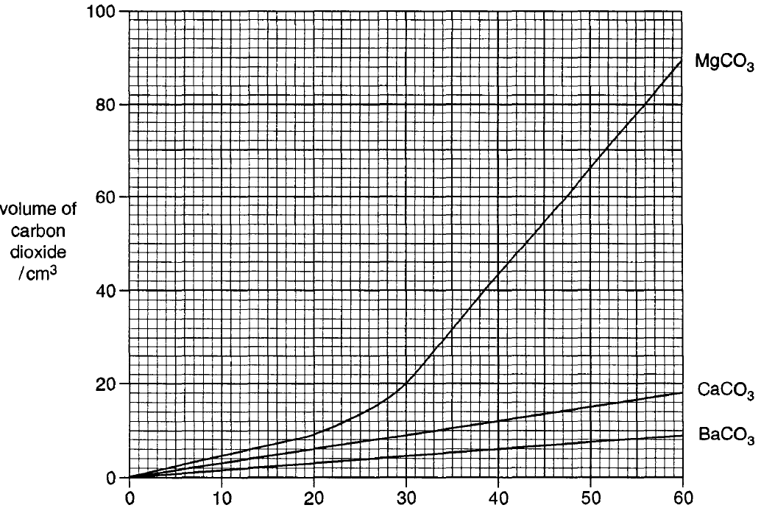
 | (a) | (i) | Write an equation to represent the thermal decomposition of barium carbonate.
 |  |  | …………………………………………………………………………………….
 |  | (ii) | Compare and explain the difference between the lattice energy of barium carbonate and its residue after decomposition.
 |  |  | …………………………………………………………………………………….  …………………………………………………………………………………….  ……………………………………………………………………………………. | [3]
 | (b) | The student used 0.98 g of BaCO₃. Calculate the mass, in two decimal places, of MgCO₃ that he should use.
 |  |  |  | [1]
4. | (c) | (i) | From the graph, identify the least thermally stable carbonate.
 |  |  | …………………………………………………………………………………….
 |  | (ii) | Clearly state one evidence from the graph to support your answer in (c)(i).
 |  |  | …………………………………………………………………………………….  ……………………………………………………………………………………. | [2]
 | (d) | The student wanted to perform the same investigation on the carbonates of the elements in Group III but found that Al₂(CO₃)₃ does not exist at room temperature. Suggest a reason for this
 |  | …………………………………………………………………………………………..  …………………………………………………………………………………………..  …………………………………………………………………………………………..  ………………………………………………………………………………………….. |  | [2]
 | (e) | The carbon dioxide gas collected from the decomposition of carbonates can behave as an ideal gas under certain experimental conditions.
 |  | (i) | State two assumptions of the kinetic theory.
1. ................................................................................................................
................................................................................................................
2. ................................................................................................................
................................................................................................................
 |  | (ii) | Would you expect carbon dioxide to behave as an ideal gas at high pressures? Explain your answer.
 |  |  | ....................................................................................................................  ....................................................................................................................  ...................................................................................................................  ................................................................................................................... | [4]

4. | (f) |  | In water obtained from the rivers of Tennessee, limescale (CaCO₃) inevitably accumulates on the inside of kettles when water is boiled. This limescale can be removed by a commercial de-scaler which contains a weak organic acid like ethanoic acid and citric acid.  The instructions for the use of a de-scaler are as follows:  “Dissolve 10 g of the powder in enough water to cover the heating element of the kettle. Switch on the kettle until the water boils, then turn it off and leave to stand for 10 minutes. Empty out the contents and rinse thoroughly before use.”  Without heating, de-scaling takes about 1 hour.
 |  |  | (i) | Write a balanced equation for the reaction between the ethanoic acid and limescale.
 |  |  |  | …………………………………………………………………………………….
 |  |  | (ii) | Explain, with aid of Boltzmann distribution curve, why heating the solution of the de-scaler increases the rate of reaction with limescale.
 |  |  | (iii) | A stronger acid is a more powerful de-scaler. Explain why ClCH₂COOH is expected to be a stronger de-scaler than ethanoic acid.
 |  |  |  | …………………………………………………………………………………….  …………………………………………………………………………………….  ……………………………………………………………………………………. | [5]
 |  | [Total: 17]

5. | Ethylenediamine, NH₂CH₂CH₂NH₂, is involved in the synthesis of compound Y as shown.
 | 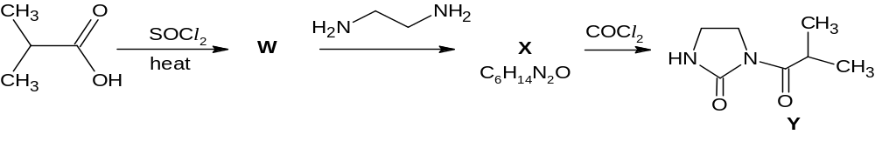
 | (a) | Suggest structures for compounds W and X. |  |  | [2]
  W : | X :
 | Compound Y is a useful intermediate for making higher substituted amines, using bromoalkanes, by the following method.
 | 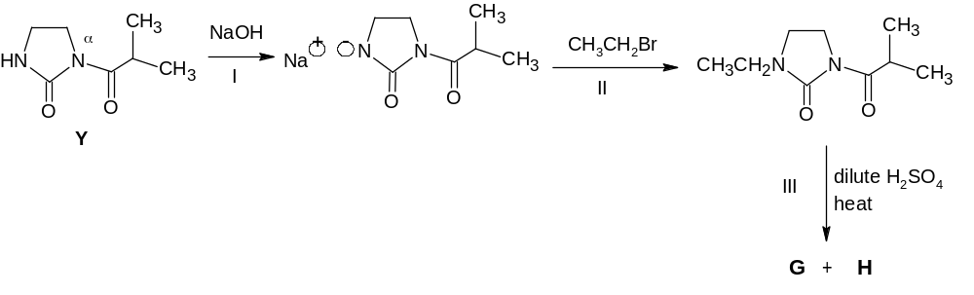
 | (b) | (i) | Suggest the type of reaction for reaction I.  ..................................................................................................................
 |  | (ii) | Suggest why NaOH is added to compound Y in reaction I before CH₃CH₂Br is added.  ..................................................................................................................
 |  | (iii) | Suggest structures for the two organic products G and H. | [5]
  G : | H :
 |  | [Total: 7]

6. | Tyrosine, proline and serine are non-essential amino acids.  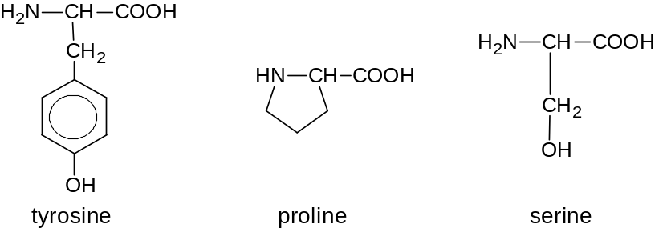
 | (a) | Draw the structure of the organic product formed when tyrosine is mixed with:
 |  | (i) | CH₃OH, in the presence of small amount of conc. H₂SO₄ | (ii) | Dilute HNO₃
 |  |  |  |  |  |  | [2]
 | (b) | (i) | Draw the structural formula of a tripeptide containing the above amino acids in the sequence tyrosine-proline-serine, showing the form in which it exists at pH 13.
 |  | (ii) | In how many ways can these three amino acids be coupled by peptide bonds to form a tripeptide? |  |  | ..................... | [3]
6. | (c)  S = 3 + 2 + 2 | When a small polypeptide S was hydrolysed in the lab, it produced a mixture of the same three amino acids mentioned, according to the following reaction:  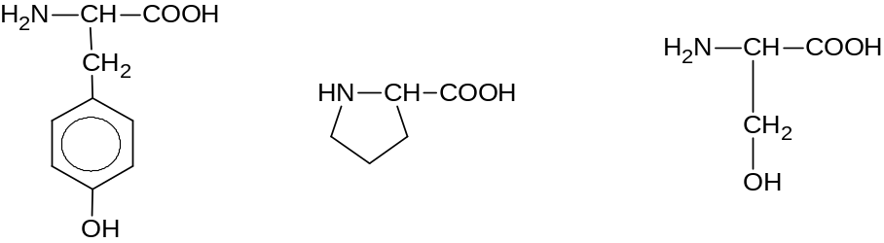  M_{r} = 181 M_{r} = 115 M_{r} = 105
 |  | (i) | How many peptide bonds were broken during this reaction? ...................
 |  | (ii) | Hence calculate the M_{r} of the polypeptide S.
 |  |  | ……………………………………………………………………………………. |  |  |  | [2]
 | (d) | In the liver, tyrosine can undergo an enzyme-catalysed conversion to DOPA, which is essential in the treatment of Parkinson’s disease.  The catalytic activity of the enzyme, which acts on tyrosine, can be inhibited by the presence of heavy metal ions, for example, Hg²⁺. |  |  |  |  | \
 |  | (i) | Explain how Hg²⁺ ions can inhibit the enzyme-catalysed reaction.
....................................................................................................................
....................................................................................................................
....................................................................................................................
....................................................................................................................
....................................................................................................................
....................................................................................................................
 |  | (ii) | Metyrosine is an amino acid that does not occur naturally but it has a structure that closely resembles tyrosine. The presence of metyrosine is known to inhibit the enzyme-catalysed conversion of tyrosine to DOPA.  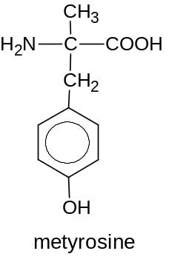  Suggest why metyrosine can inhibit the enzyme-catalysed reaction.
 |  |  | ....................................................................................................................  .................................................................................................................... |  |  |  | [3]
 |  |  | [Total: 10]

